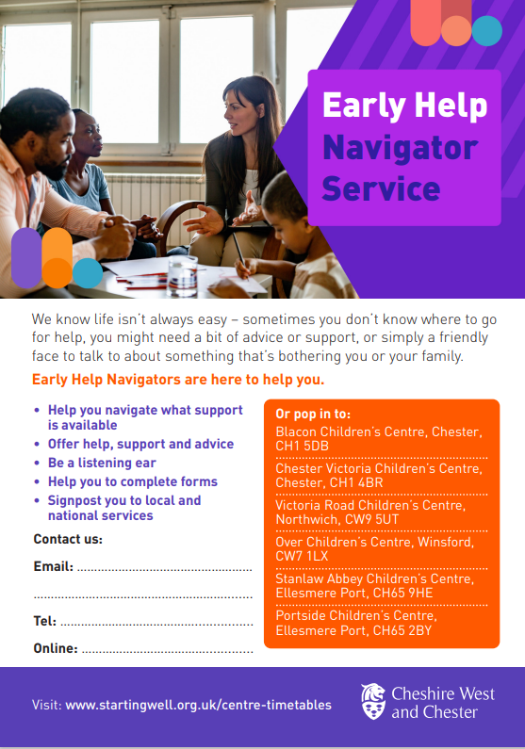



**Attend one of our drop-in locations:**

**Stanlaw Abbey Children’s Centre** – Mondays 9am -4:00pm

**Portside Children’s Centre** – Mondays 12:30pm - 3:30pm

**Wolverham Community Centre** – **The People’s Pantry** – Alternate Wednesdays April 16th, 30th, May 14th, 28th, June 11th, 25th **10am – 11:30am**

**Ellesmere Port Library - Baby Rhyme Time**  – Tuesdays – April 22nd , May 20th, June 17th , July 15th **10-11:30**

**Toddler Rhyme Time** – Wednesdays – April 9th , May 7th, June 4th, July 2nd **10-11:30**

**Let’s Talk – Trinity Church, Whitby Rd –** Alternate Thursdays **10am-12pm** - May 1st, May 15th, May 29th, May 12th

**Bridge Community Farm** – Mill Lane, Great Sutton, CH66 3NE- Alternate Wednesdays - May 21st, June 4th, June 18th, July 2nd, July 16th **12:30 – 2**

**Alternatively, you can scan the QR code at the top of this page to book an appointment in the community**

* Be a listening ear
* Provide help, support and advice with family life
* Signpost you to local and national support
* Help with completing forms
* Attend GP appointments with your family
* Access food and kids bank referrals

Visit: [www.livewell.cheshirewestandchester.gov.uk](http://www.livewell.cheshirewestandchester.gov.uk) –

Earky Help Navigator Service